**1. ABSTRACT**

In Malaysia, the usage of Smartphone is growing rapidly, and businesses have gained a greater profit. Survey that had been done by Malaysian Communications and Multimedia Commission (2016) showed that the use of Smartphone in Malaysia is increasing from year to year. The use of the Smartphone is rising due to the benefits that the consumers could obtain. Smartphone offers a great capability such as can access to internet connection, download interesting applications, can do a variety functions of communications using instant messaging on WhatsApp, Skype, Facebook and other social media sites, video calling and audio calling media player, location-awareness function, managing personal time schedule and editing documents

Other than that, based on the research in 2016, price, smartphone specification and brand name might be related to the preferences of the consumer and features that were associated with the Smartphone. The preferences are crucial to further examine as it could lead to consumers buying decision. Therefore, this study will focus in investigating these preferences which are brand name, operating system, size of random access memory (RAM), size of internal storage and budget willing for a new smartphone as the independent variables and smartphone preferences as the dependent variable.

The study focused on the relationship between Smartphone’s preferences with smartphone specifications among consumers. We had a survey on smartphone preferences and there are 162 respondent which are mainly from IIUM community, friends and family. Based on the statistical analysis, all variables namely brand name, smartphone specifications like operating system, size of random access memory (RAM), size of internal storage and budget willing for a new smartphone have a positive relationship with the consumers smartphone preferences.

Logically, we assume that consumer prefer a smartphone with a well-known brand and operating system, a bigger storage for random access memory (RAM), bigger storage for internal memory and an average budget willingly pay for a new smartphone.

As a conclusion, this study will show that smartphone with well-known brand and operating system with a big storage for both RAM and internal storage to ease with everyday activities. The budget expenses we are expecting are on the average level where it is not too expensive or too cheap.

**2. INTRODUCTION**

Our survey target audience are people age 13 and above. The means of this research is via online survey form which is Google Form, and we managed to get 162 respondents by survey and that is excluded the corrupted data. This survey contains two part which is one for consumer’s current smartphone and second is the preferred smartphone.

In the survey, we asked them if they currently have a smartphone and if they prefer to change to a new preferred smartphone. This question is followed by the smartphone specification of the current and preferred smartphones. Lastly is a question about the range of price budget for the preferred smartphone. These questions are to identify the preferred specification for the smartphone among the respondent.

|  |  |  |
| --- | --- | --- |
| Smartphone brand   1. Samsung 2. iPhone 3. Vivo 4. Asus 5. Oppo 6. Xiaomi 7. Blackberry 8. HTC 9. Huawei 10. Lenovo 11. Nokia 12. One Plus 13. Pixel 14. Sony | Operating system   1. IOS 2. Android 3. Windows Phone 4. Blackberry | Random Access Memory (RAM) storage   1. 8 GB 2. 16 GB 3. 32 GB 4. 64 GB 5. 128 GB 6. Above 128 GB |
| Random Access Memory (RAM) storage   1. 1 GB 2. 2 GB 3. 3 GB 4. 4 GB 5. Above 4 GB | Budget   1. RM 0 – RM 500 2. RM 500 – RM 1000 3. RM 1000 – RM 1500 4. RM 1500 – RM 2000 5. RM 2000 – RM 2500 6. RM 2500 – RM 3000 7. Above RM 3000 |

**3. DATASET**

**3.1 Current smartphones specifications**

|  |  |  |  |
| --- | --- | --- | --- |
| Brand name | Operating System (OS) | Random Access Memory (RAM) | internal storage |
| Asus | Android | 2 GB | 16 GB |
| Samsung | Android | 2 GB | 16 GB |
| Sony | Android | 3 GB | 16 GB |
| Xiaomi | Android | 2 GB | 16 GB |
| Samsung | Android | 4 GB | 16 GB |
| Samsung | Android | Above 4 GB | 16 GB |
| Samsung | Android | Above 4 GB | 16 GB |
| Samsung | Android | Above 4 GB | 16 GB |
| Samsung | Android | 3 GB | 32 GB |
| Xiaomi | Android | 3 GB | 32 GB |
| Samsung | Android | 3 GB | 32 GB |
| Samsung | Android | 4 GB | 32 GB |
| Samsung | Android | 3 GB | 32 GB |
| Pixel | Android | 4 GB | 32 GB |
| Samsung | Android | 4 GB | 32 GB |
| Samsung | Android | Above 4 GB | 32 GB |
| Samsung | Android | Above 4 GB | 64 GB |
| Sony | Android | 3 GB | 8 GB |
| Xiaomi | Android | 3 GB | 8 GB |
| Samsung | Android | 4 GB | 8 GB |
| Lenovo | Android | Above 4 GB | 8 GB |
| Samsung | Android | Above 4 GB | 8 GB |
| iPhone | IOS | 2 GB | 64 GB |
| Asus | Android | 2 GB | 16 GB |
| Samsung | Android | 2 GB | 16 GB |
| Oppo | Android | 4 GB | 16 GB |
| Oppo | Android | 3 GB | 64 GB |
| Vivo | Android | 4 GB | 8 GB |
| Asus | Android | Above 4 GB | 8 GB |
| iPhone | IOS | 2 GB | 128 GB |
| iPhone | IOS | 2 GB | 16 GB |
| iPhone | IOS | 2 GB | 16 GB |
| iPhone | IOS | 3 GB | 16 GB |
| iPhone | IOS | Above 4 GB | 16 GB |
| iPhone | IOS | Above 4 GB | 128 GB |
| iPhone | IOS | 3 GB | 32 GB |
| Vivo | IOS | 4 GB | 32 GB |
| iPhone | IOS | 3 GB | 64 GB |
| iPhone | IOS | 4 GB | 64 GB |
| iPhone | IOS | 4 GB | 64 GB |
| Vivo | Android | 4 GB | 16 GB |
| Nokia | Windows Phone | 2 GB | 64 GB |
| Oppo | Android | Above 4 GB | 128 GB |
| Samsung | Android | 2 GB | 16 GB |
| Samsung | Android | 3 GB | 32 GB |
| Xiaomi | Android | 3 GB | 32 GB |
| Xiaomi | Android | 3 GB | 32 GB |
| Oppo | Android | 4 GB | 32 GB |
| Samsung | Android | 4 GB | 32 GB |
| Samsung | Android | 4 GB | 32 GB |
| Vivo | Android | 4 GB | 32 GB |
| Oppo | Android | 1 GB | 64 GB |
| Sony | Android | 3 GB | 64 GB |
| Xiaomi | Android | 3 GB | 64 GB |
| HTC | Android | 4 GB | 64 GB |
| Samsung | Android | 4 GB | 64 GB |
| Samsung | Android | 4 GB | 64 GB |
| Vivo | Android | 4 GB | 64 GB |
| Xiaomi | Android | 4 GB | 64 GB |
| Xiaomi | Android | 4 GB | 64 GB |
| Oppo | Android | Above 4 GB | 64 GB |
| Samsung | Android | Above 4 GB | 64 GB |
| Samsung | Android | 1 GB | 8 GB |
| Asus | Android | 2 GB | 8 GB |
| Asus | Android | 2 GB | 8 GB |
| huawei | Android | 2 GB | 8 GB |
| Samsung | Android | 2 GB | 8 GB |
| Huawei | Android | 3 GB | 8 GB |
| Xiaomi | Android | Above 4 GB | Above 128 GB |
| iPhone | IOS | 2 GB | 128 GB |
| iPhone | IOS | 2 GB | 128 GB |
| iPhone | IOS | 2 GB | 128 GB |
| iPhone | IOS | Above 4 GB | 128 GB |
| iPhone | IOS | Above 4 GB | 128 GB |
| iPhone | IOS | Above 4 GB | 128 GB |
| iPhone | IOS | 2 GB | 16 GB |
| iPhone | IOS | 2 GB | 32 GB |
| iPhone | IOS | 2 GB | 32 GB |
| iPhone | IOS | Above 4 GB | 32 GB |
| iPhone | IOS | 4 GB | 64 GB |
| iPhone | IOS | Above 4 GB | 64 GB |
| Oppo | Android | 1 GB | 16 GB |
| Samsung | Android | 1 GB | 16 GB |
| Vivo | Android | 2 GB | 16 GB |
| Lenovo | Android | 2 GB | 16 GB |
| Lenovo | Android | 2 GB | 16 GB |
| Samsung | Android | 2 GB | 16 GB |
| Lenovo | Android | 2 GB | 16 GB |
| Samsung | Android | Above 4 GB | 16 GB |
| Oppo | Android | Above 4 GB | 16 GB |
| Samsung | Android | Above 4 GB | 16 GB |
| Asus | Android | 3 GB | 32 GB |
| Xiaomi | Android | 3 GB | 32 GB |
| Xiaomi | Android | 4 GB | 32 GB |
| Xiaomi | Android | 3 GB | 32 GB |
| Samsung | Android | 3 GB | 32 GB |
| Samsung | Android | 3 GB | 32 GB |
| Samsung | Android | 4 GB | 32 GB |
| Samsung | Android | Above 4 GB | 32 GB |
| Samsung | Android | 3 GB | 64 GB |
| Oppo | Android | 3 GB | 64 GB |
| Samsung | Android | 4 GB | 64 GB |
| oneplus | Android | 2 GB | 64 GB |
| Samsung | Android | 3 GB | 64 GB |
| Vivo | Android | 3 GB | 64 GB |
| Vivo | Android | 4 GB | 64 GB |
| oneplus | Android | Above 4 GB | 64 GB |
| Lenovo | Android | 2 GB | 8 GB |
| Samsung | Android | 1 GB | 8 GB |
| Samsung | Android | 1 GB | 8 GB |
| Samsung | Android | 1 GB | 8 GB |
| Samsung | Android | 1 GB | 8 GB |
| Xiaomi | Android | 2 GB | 8 GB |
| Xiaomi | Android | 2 GB | 8 GB |
| Xiaomi | Android | 4 GB | 8 GB |
| Samsung | Android | 1 GB | 8 GB |
| Lenovo | Android | 2 GB | 8 GB |
| Asus | Android | 4 GB | 8 GB |
| Nokia | Windows Phone | 3 GB | 32 GB |
| Nokia | Windows Phone | Above 4 GB | Above 128 GB |
| Oppo | Android | 1 GB | 16 GB |
| Oppo | Android | 1 GB | 16 GB |
| Oppo | Android | 2 GB | 16 GB |
| Oppo | Android | 2 GB | 16 GB |
| Oppo | Android | 2 GB | 16 GB |
| Samsung | Android | 2 GB | 16 GB |
| Vivo | Android | 2 GB | 16 GB |
| Oppo | Android | 2 GB | 16 GB |
| Huawei | Android | 4 GB | 16 GB |
| Asus | Android | 2 GB | 32 GB |
| Samsung | Android | 4 GB | 32 GB |
| Oppo | Android | 3 GB | 32 GB |
| Oppo | Android | 4 GB | 32 GB |
| Oppo | Android | Above 4 GB | 32 GB |
| Asus | Android | 4 GB | 64 GB |
| Nokia | Android | 4 GB | 64 GB |
| Oppo | Android | 4 GB | 64 GB |
| Samsung | Android | 2 GB | 8 GB |
| Samsung | Android | 2 GB | 8 GB |
| Oppo | Android | 3 GB | 8 GB |
| Oppo | Android | 4 GB | 8 GB |
| iPhone | IOS | 3 GB | 128 GB |
| iPhone | IOS | 4 GB | 128 GB |
| iPhone | IOS | 2 GB | 16 GB |
| iPhone | IOS | 1 GB | 16 GB |
| iPhone | IOS | Above 4 GB | 16 GB |
| iPhone | IOS | Above 4 GB | 16 GB |
| iPhone | IOS | Above 4 GB | 16 GB |
| iPhone | IOS | 1 GB | 32 GB |
| iPhone | IOS | 4 GB | 32 GB |
| iPhone | IOS | 4 GB | 32 GB |
| iPhone | IOS | 2 GB | 64 GB |
| iPhone | IOS | 4 GB | 64 GB |
| iPhone | IOS | 4 GB | 64 GB |
| iPhone | IOS | Above 4 GB | 64 GB |
| iPhone | IOS | Above 4 GB | 64 GB |
| iPhone | IOS | Above 4 GB | 64 GB |
| Nokia | Windows Phone | 2 GB | 32 GB |
| Vivo | Android | 1 GB | 16 GB |
| Asus | Android | 3 GB | 32 GB |
| Nokia | Android | Above 4 GB | Above 128 GB |

Table 3.1 Dataset for current smartphone specifications

**3.2 Preferred smartphone specifications**

|  |  |  |  |
| --- | --- | --- | --- |
| Brand name | Operating System (OS) | Random Access Memory (RAM) | internal storage |
| Samsung | Android | Above 4 GB | Above 128 GB |
| Vivo | Android | Above 4 GB | Above 128 GB |
| Samsung | Android | Above 4 GB | 64 GB |
| Xiaomi | Android | Above 4 GB | 32 GB |
| Samsung | Android | Above 4 GB | 64 GB |
| Samsung | Android | Above 4 GB | 64 GB |
| Xiaomi | Android | Above 4 GB | Above 128 GB |
| Iphone | Android | Above 4 GB | 64 GB |
| Oppo | Android | 4 GB | 64 GB |
| Samsung | Android | 4 GB | 128 GB |
| Samsung | Android | Above 4 GB | 16 GB |
| Xiaomi | Android | 4 GB | 64 GB |
| Vivo | Android | Above 4 GB | 128 GB |
| Iphone | Android | Above 4 GB | Above 128 GB |
| Samsung | Android | 4 GB | 32 GB |
| Samsung | Android | Above 4 GB | Above 128 GB |
| Samsung | Android | Above 4 GB | 128 GB |
| One Plus | Android | Above 4 GB | Above 128 GB |
| Samsung | Android | 4 GB | 64 GB |
| Xiaomi | Android | 4 GB | 128 GB |
| Iphone | Android | Above 4 GB | 128 GB |
| Asus | Android | 4 GB | 64 GB |
| Samsung | Android | 4 GB | 32 GB |
| Xiaomi | Android | 4 GB | 128 GB |
| Iphone | Android | Above 4 GB | Above 128 GB |
| One Plus | Android | Above 4 GB | Above 128 GB |
| Oppo | Android | Above 4 GB | 64 GB |
| Samsung | Android | Above 4 GB | 128 GB |
| Samsung | Android | 4 GB | 128 GB |
| Samsung | Android | 4 GB | 128 GB |
| Sony | Android | 3 GB | 128 GB |
| Samsung | Android | 2 GB | 64 GB |
| Xiaomi | Android | 1 GB | 64 GB |
| Xiaomi | Android | 4 GB | 128 GB |
| Samsung | Android | 1 GB | 64 GB |
| Samsung | Android | 2 GB | Above 128 GB |
| Samsung | Android | 3 GB | 64 GB |
| Nokia | Android | 4 GB | Above 128 GB |
| Blackberry | Blackberry | 4 GB | Above 128 GB |
| Iphone | IOS | Above 4 GB | 128 GB |
| Iphone | IOS | 3 GB | Above 128 GB |
| Iphone | IOS | Above 4 GB | Above 128 GB |
| Iphone | IOS | Above 4 GB | Above 128 GB |
| Iphone | IOS | Above 4 GB | Above 128 GB |
| Iphone | IOS | Above 4 GB | Above 128 GB |
| Iphone | IOS | Above 4 GB | Above 128 GB |
| Samsung | Android | Above 4 GB | Above 128 GB |
| Iphone | IOS | 4 GB | 64 GB |
| Iphone | IOS | Above 4 GB | Above 128 GB |
| Iphone | IOS | 4 GB | 64 GB |
| Iphone | IOS | Above 4 GB | 64 GB |
| Iphone | IOS | 4 GB | 128 GB |
| Iphone | IOS | 3 GB | 64 GB |
| Iphone | IOS | Above 4 GB | Above 128 GB |
| Iphone | IOS | Above 4 GB | 64 GB |
| Iphone | IOS | Above 4 GB | 64 GB |
| Iphone | IOS | Above 4 GB | 64 GB |
| Samsung | Android | Above 4 GB | 64 GB |
| Iphone | IOS | Above 4 GB | Above 128 GB |
| Iphone | IOS | Above 4 GB | Above 128 GB |
| Iphone | IOS | Above 4 GB | Above 128 GB |
| Iphone | IOS | 4 GB | Above 128 GB |
| Iphone | IOS | 4 GB | 128 GB |
| Iphone | IOS | 4 GB | 32 GB |
| Iphone | IOS | Above 4 GB | 64 GB |
| Iphone | IOS | Above 4 GB | 64 GB |
| Iphone | IOS | 4 GB | 64 GB |
| Iphone | IOS | 4 GB | 64 GB |
| Iphone | IOS | Above 4 GB | Above 128 GB |
| Iphone | IOS | Above 4 GB | Above 128 GB |
| Iphone | IOS | Above 4 GB | 128 GB |
| Iphone | IOS | 4 GB | 64 GB |
| Iphone | IOS | 3 GB | 128 GB |
| Iphone | IOS | 2 GB | 16 GB |
| Iphone | IOS | 4 GB | 64 GB |
| Iphone | IOS | 4 GB | 64 GB |
| Iphone | IOS | Above 4 GB | 128 GB |
| Iphone | IOS | 4 GB | 128 GB |
| Iphone | IOS | Above 4 GB | 64 GB |
| Pixel | Android | Above 4 GB | Above 128 GB |
| Samsung | Android | Above 4 GB | Above 128 GB |
| Samsung | Android | Above 4 GB | Above 128 GB |
| Samsung | Android | 4 GB | 128 GB |
| Xiaomi | Android | Above 4 GB | Above 128 GB |
| Samsung | Android | 4 GB | 64 GB |
| Samsung | Android | 4 GB | 64 GB |
| Samsung | Android | Above 4 GB | Above 128 GB |
| Samsung | Android | Above 4 GB | Above 128 GB |
| Samsung | Android | 4 GB | 128 GB |
| Iphone | Android | 3 GB | 128 GB |
| Samsung | Android | 3 GB | 128 GB |
| Samsung | Android | 4 GB | 64 GB |
| Samsung | Android | Above 4 GB | 64 GB |
| Pixel | Android | Above 4 GB | 64 GB |
| Samsung | Android | Above 4 GB | 128 GB |
| Iphone | Android | Above 4 GB | 128 GB |
| Samsung | Android | Above 4 GB | Above 128 GB |
| Sony | Android | Above 4 GB | 64 GB |
| Xiaomi | Android | Above 4 GB | 64 GB |
| Vivo | Android | Above 4 GB | 64 GB |
| Iphone | Android | Above 4 GB | 64 GB |
| Samsung | Android | Above 4 GB | 64 GB |
| Huawei | Android | Above 4 GB | Above 128 GB |
| Iphone | IOS | 1 GB | 8 GB |
| Oppo | IOS | 4 GB | 128 GB |
| Iphone | IOS | 4 GB | 64 GB |
| Iphone | IOS | Above 4 GB | 64 GB |
| Iphone | IOS | 4 GB | Above 128 GB |
| Iphone | IOS | 4 GB | Above 128 GB |
| Iphone | IOS | Above 4 GB | Above 128 GB |
| Iphone | IOS | Above 4 GB | Above 128 GB |
| Iphone | IOS | 3 GB | 64 GB |
| Iphone | IOS | 3 GB | 64 GB |
| Iphone | IOS | Above 4 GB | 64 GB |
| Iphone | IOS | 2 GB | Above 128 GB |
| Iphone | IOS | 2 GB | 128 GB |
| Iphone | IOS | Above 4 GB | Above 128 GB |
| Iphone | IOS | Above 4 GB | Above 128 GB |
| Iphone | IOS | Above 4 GB | Above 128 GB |
| Iphone | IOS | 4 GB | 64 GB |
| Vivo | Android | Above 4 GB | Above 128 GB |
| Nokia | Windows Phone | Above 4 GB | 64 GB |

Table 3.2 Dataset for preferred smartphone specifications

**4. PRELIMINARY ANALYSIS (MATHEMATICAL PROCESSES)**

4.1 ANALYSIS ON SMARTPHONE’S BRAND

Figure 4.1 Histogram of current and preferred smartphone’s brand name

|  |  |  |
| --- | --- | --- |
| **Brand name** | **Current smartphone** | **Preferred smartphone** |
| Asus | 10 | 1 |
| blackberry | 0 | 1 |
| HTC | 1 | 0 |
| Huawei | 3 | 1 |
| iPhone | 39 | 61 |
| Lenovo | 6 | 0 |
| Nokia | 6 | 2 |
| OnePlus | 2 | 2 |
| Oppo | 21 | 3 |
| Pixel | 1 | 2 |
| Samsung | 44 | 34 |
| Sony | 3 | 2 |
| Vivo | 10 | 4 |
| Xiaomi | 15 | 9 |

Table 4.4 Frequency of current and preferred smartphone’s brand

**Current smartphone’s brand**

**Mean**

**Modal classes = Samsung**

**Mode = 44**

**Variance**

**Standard Deviation**

* Using the histogram above, we can conclude that this data is random distribution.

**Chebyshev’s Theorem (Current smartphone’s brand)**

Based on the above calculations, the mean is 10.73 and the standard deviation is 13.86:

Chebyshev’s theorem states that;

At least three-fourths, or 75% of the data values will fall between -16.99 and 38.45:

and

and

At least eight-ninths, or 88.89% of the data values will fall between -30.85 and 52.31:

and

and

At least 93.75% of the data values will fall between -44.71 and 66.17:

and

and

Hence, the mean falls within 4 standard deviations.

**Preferred smartphone’s brand**

**Mean**

**Modal classes = iPhone**

**Mode = 61**

**Variance**

**Standard Deviation**

* Using the histogram above, we can conclude that this data is random distribution.

**Chebyshev’s Theorem (Preferred smartphone’s brand)**

Based on the above calculations, the mean is 8.13 and the standard deviation is 16.92:

Chebyshev’s theorem states that;

At least three-fourths, or 75% of the data values will fall between -25.54 and 41.97:

and

and

At least eight-ninths, or 88.89% of the data values will fall between -42.63 and 58.89:

and

and

At least 93.75% of the data values will fall between -59.55 and 75.81:

and

and

Hence, the mean falls within 4 standard deviations.

4.2 ANALYSIS ON SMARTPHONE’S SPECIFICATION (OPERATING SYSTEM)

Figure 4.2 Histogram of current and preferred smartphone’s operating system

|  |  |  |
| --- | --- | --- |
| **Operating system** | **Current smartphone** | **Preferred smartphone** |
| Android | 117 | 65 |
| Blackberry | 0 | 1 |
| IOS | 40 | 55 |
| Windows Phone | 4 | 1 |

Table 4.4 Frequency of current and preferred smartphone’s operating system

**Current smartphone’s operating system**

**Mean**

**Modal classes = Android**

**Mode = 117**

**Variance**

**Standard Deviation**

* Using the histogram above, we can conclude that this data is negatively skewed.

**Chebyshev’s Theorem (Current smartphone’s operating system)**

Based on the above calculations, the mean is and the standard deviation is :

Chebyshev’s theorem states that;

At least three-fourths, or 75% of the data values will fall between and :

and

and

At least eight-ninths, or 88.89% of the data values will fall between and:

and

and

At least 93.75% of the data values will fall between and :

and

and

Hence, the mean falls within 4 standard deviations.

**Preferred smartphone’s operating system**

**Mean**

**Modal classes = Android**

**Mode = 65**

**Variance**

**Standard Deviation**

* Using the histogram above, we can conclude that this data is positively skewed.

**Chebyshev’s Theorem (preferred smartphone’s operating system)**

Based on the above calculations, the mean is and the standard deviation is :

Chebyshev’s theorem states that;

At least three-fourths, or 75% of the data values will fall between and :

and

and

At least eight-ninths, or 88.89% of the data values will fall between and :

and

and

At least 93.75% of the data values will fall between and :

and

and

Hence, the mean falls within 4 standard deviations.

4.3 ANALYSIS ON SMARTPHONE’S SPECIFICATION (RAM STORAGE)

Figure 4.3 Histogram of current and preferred smartphone’s RAM storage

|  |  |  |
| --- | --- | --- |
| **RAM storage** | **Current smartphone** | **Preferred smartphone** |
| 1 GB | 14 | 3 |
| 2 GB | 43 | 5 |
| 3 GB | 31 | 9 |
| 4 GB | 40 | 36 |
| Above 4 GB | 33 | 69 |

Table 4.3 Frequency of current and preferred smartphone’s RAM storage

**Current smartphone’s RAM storage**

**Mean**

**Modal classes = 2 GB**

**Mode = 43**

**Variance**

=

=

**Standard Deviation**

* Using the histogram above, we can conclude that this data is positively skewed.

**Chebyshev’s Theorem (Current smartphone’s RAM)**

Based on the above calculations, the mean is 32.2 and the standard deviation is 11.30044:

Chebyshev’s theorem states that;

At least three-fourths, or 75% of the data values will fall between 9.5992 and 54.8008:

and

and

At least eight-ninths, or 88.89% of the data values will fall between -1.7012 and 66.1012:

and

and

At least 93.75% of the data values will fall between -13.0016 and 77.4016:

and

and

Hence, the mean falls within 4 standard deviations.

**Preferred smartphone’s RAM storage**

**Mean**

**Modal classes = Above 4 GB**

**Mode = 3**

**Variance**

**Standard Deviation**

* Using the histogram above, we can conclude that this data is positively skewed.

**Chebyshev’s Theorem (Preferred smartphone’s RAM)**

Based on the above calculations, the mean is 24.4 and the standard deviation is 28.26305:

Chebyshev’s theorem states that;

At least three-fourths, or 75% of the data values will fall between 9.5992 and 54.8008:

and

and

At least eight-ninths, or 88.89% of the data values will fall between -1.7012 and 66.1012:

and

and

At least 93.75% of the data values will fall between -13.0016 and 77.4016:

and

and

Hence, the mean falls within 4 standard deviations.

4.4 ANALYSIS ON SMARTPHONE’S SPECIFICATION (INTERNAL STORAGE)

Figure 4.4 Histogram of current and preferred smartphone’s internal storage

|  |  |  |
| --- | --- | --- |
| **Internal storage** | **Current smartphone** | **Preferred smartphone** |
| 8 GB | 28 | 1 |
| 16 GB | 43 | 2 |
| 32 GB | 39 | 4 |
| 64 GB | 37 | 46 |
| 128 GB | 11 | 26 |
| Above 128 GB | 3 | 43 |

Table 4.4 Frequency of current and preferred smartphone’s internal storage

**Current smartphone internal storage**

**Mean**

**Modal class = no modal class**

**Mode = no mode**

Variance

**Standard Deviation**

* Using the histogram above, we can conclude that this data is right-skewed.

**Chebyshev’s Theorem**

Based on the above calculations, the mean is 26.833 and the standard deviation is 16.327:

Chebyshev’s theorem states that;

At least three-fourths, or 75% of the data values will fall between 9.5992 and 54.8008:

and

and

At least eight-ninths, or 88.89% of the data values will fall between -1.7012 and 66.1012:

and

and

Hence, the mean falls within 3 standard deviations.

**Preferred smartphone’s internal storage**

**Mean**

**Modal class = no modal class**

**Mode = no mode**

**Variance**

**Standard Deviation**

* Using the histogram above, we can conclude that this data is bimodal.

**Chebyshev’s Theorem**

Based on the above calculations, the mean is 20.3 and the standard deviation is 20.89:

Chebyshev’s theorem states that;

At least three-fourths, or 75% of the data values will fall between 9.5992 and 54.8008:

and

and

At least eight-ninths, or 88.89% of the data values will fall between -1.7012 and 66.1012:

and

and

Hence, the mean falls within 3 standard deviations.

4.5 ANALYSIS ON PREFERRED SMARTPHONE’S BUDGET

Figure 4.5 Histogram of preferred smartphone’s budget

|  |  |
| --- | --- |
| **Budget** | **Tally** |
| RM 0 - RM 500 | 7 |
| RM 500 - RM 1000 | 19 |
| RM 1000 - RM 1500 | 26 |
| RM 1500 - RM 2000 | 34 |
| RM 2000 - RM 2500 | 17 |
| RM 2500 - RM 3000 | 11 |
| Above RM 3000 | 8 |

Table 4.5 Frequency of preferred smartphone’s budget

**Mean**

**Modal classes = RM 1500 - RM 2000**

**Mode = 34**

**Variance**

**Standard Deviation**

* Using the histogram above, we can conclude that this data is normally distributed.

**Chebyshev’s Theorem (Preferred smartphone’s budget)**

Based on the above calculations, the mean is 17.43 and the standard deviation is 9.91:

Chebyshev’s theorem states that;

At least three-fourths, or 75% of the data values will fall between -2.39 and 37.25:

and

and

At least eight-ninths, or 88.89% of the data values will fall between -12.3 and 47.16:

and

and

At least 93.75% of the data values will fall between -22.21and 57.07:

and

and

Hence, the mean falls within 4 standard deviations.

1. **RANDOM TEST**

**5.1 Run test**

M F MMM FFF M FF MMMM F MM FFFF MM FFFFF M FFFFFFF M F MM FFF MMM F M FFF MMMMM F M FFFFFF M F M FFF MM FFFFFFF MMMM FFF M FF M F M F MM F MMMMMMMMMMMMM F M F MM FFF MM FFFFF MMM FFFFFF MM FFFFFFFF MM FF MM FF MMM FF M FF M F

|  |  |
| --- | --- |
| **Run** | **Position** |
| 1 | M |
| 2 | F |
| 3 | MMM |
| 4 | FFF |
| 5 | M |
| 6 | FF |
| 7 | MMMM |
| 8 | F |
| 9 | MM |
| 10 | FFFF |
| 11 | MM |
| 12 | FFFFF |
| 13 | M |
| 14 | FFFFFFF |
| 15 | M |
| 16 | F |
| 17 | MM |
| 18 | FFF |
| 19 | MMM |
| 20 | F |
| 21 | M |
| 22 | FF |
| 23 | MMMMM |
| 24 | F |
| 25 | M |
| 26 | FFFFFF |
| 27 | M |
| 28 | F |
| 29 | M |
| 30 | FFF |
| 31 | MM |
| 32 | FFFFFFF |
| 33 | MMMM |
| 34 | FFF |
| 35 | M |
| 36 | FF |
| 37 | M |
| 38 | F |
| 39 | M |
| 40 | F |
| 41 | MM |
| 42 | F |
| 43 | MMMMM  MMMMM  MMM |
| 44 | F |
| 45 | M |
| 46 | F |
| 47 | MM |
| 48 | FFF |
| 49 | MM |
| 50 | FFFFF |
| 51 | MMM |
| 52 | FFFFFF |
| 53 | MM |
| 54 | FFFFFFFF |
| 55 | MM |
| 56 | FF |
| 57 | MM |
| 58 | FF |
| 59 | MMM |
| 60 | FF |
| 61 | M |
| 62 | FF |
| 63 | M |
| 64 | F |

Table 5.1 Number of runs by gender

𝐻0: 𝐴𝑟𝑟𝑎𝑛𝑔𝑒𝑚𝑒𝑛𝑡 𝑖𝑠 𝑟𝑎𝑛𝑑𝑜𝑚

𝐻1: 𝐴𝑟𝑟𝑎𝑛𝑔𝑒𝑚𝑒𝑛𝑡 𝑖𝑠 𝑛𝑜𝑡 𝑟𝑎𝑛𝑑𝑜𝑚

**𝛼 = 0.05**,  **= 0.025**, 𝑡ℎ𝑢𝑠, **𝑉 = ±1.96**, **= 64**, **= 72**,  **= 90**

From the calculation, the test value is -2.713 which is lower than -1.96. Therefore, the null hypothesis is rejected.

There is not enough evidence to accept the hypothesis that the arrangement is random.

Therefore, this shows that our data is not collected randomly.

1. **FINAL ANALYSIS**

The study is attempted to investigate the relationship between smartphone’s preferences with consumer buying decision. The research focused on a correlational study where convenience sampling technique was chosen. Data were collected from random respondent through online survey. A total of 162 out of 165 respondents were chosen as a sample size for this study and the remaining are the corrupted respond with are excluded from the sample. The questionnaire consists of two sections. Section A is about the respondent’s current smartphone specification. Meanwhile, Section B comprised of the preferred smartphone specifications and a budget for the preferred smartphone.

We made use of the measurement of central tendencies such as, mean, modal class, mode, midrange, variance, and standard deviation. Histograms were also used other than pie charts to check the skewness of the data and Chebyshev’s theorem to check on how much data values falls within multiple of standard deviation from the mean.

We found that consumers tend to buy a well-known brand of smartphone in the market. We discovered that Samsung brand was the most current brand followed by iPhone, Oppo, Xiaomi, Vivo and Asus and iPhone is the most preferred brand followed by Samsung, Xiaomi and etc (refer to table 4.1 and figure 4.1). Consumers desired a famous brand of smartphone that have features like touch screen interaction and quickly access to information with less disruption. We also acknowledge that smartphone’s brand which has favorable product attributes would influenced preferences of consumers decision.

It is a serious competition by both producer of android and IOS as they have the majority preferred operating system by the consumer while window phone and blackberry operating system are the choice of the minority in the nowadays community (refer to table 4.2 and figure 4.2). This preference is influenced by the well-known brand and their respective operating system. Each operating system has their own advantages and disadvantages through their usage and application.

For random access memory (RAM) storage, consumer tend to go for bigger storage as they give better performance for the smartphone. As the survey had showed, option for above 4 GB RAM storage is chosen by majority for the preferred RAM storage and followed by 4 GB, 3 GB, 2 GB and 1 GB (refer to table 4.3 and figure 4.3). This specification is rather one of the most important component on smartphone preferences as it will affect the performance of the smartphone and influence the price of the smartphone.

Internal storage is the second most important specification for selecting a smartphone this specification is vital as it could determine the level of consumer’s satisfaction towards each product. Most consumer preferred a large storage for the internal memory of the smartphone which is very convenience for the user to store many data such as pictures, video, documents and application data. As shown in the survey, consumer is satisfied with the third largest storage in the option given which is 64 GB internal memory storage. Still the largest option for the internal memory storage which is above 128 GB is the second preferred and 128 GB storage as the third most preferred option (refer to table 4.4 and figure 4.4).

As assumed by our research team, consumer tend to go for the average budget for the preferred smartphone and not for the highest budget (refer to table 4.5 and figure 4.5). This may have influenced by the company that offer product with high specification but with low prices such as Xiaomi, Oppo and Vivo. There is some consumer preferred with budget with below RM 1500 as many smartphones are priced in that range are equipped with high specification. There is also a few consumers that preferred to go for big budget like above RM 3000 as to follow technology trend or the comfortable usage of the smartphone on personal satisfaction.

There is not enough evidence to accept the hypothesis stated in the test to prove that the arrangement is random. (Refer to table 5.1 Run Test) The test result we calculated is out of range from the critical region. This proves that our data is not collected randomly. This may have caused by the respondent are only within our range of community in the university or even only within the kulliyyah of information communication and technology.

Based on the data obtained and organized, our proposed hypothesis is partially accepted and partially reject, which are consumer prefer a smartphone with a well-known brand and operating system, a bigger storage for random access memory (RAM), bigger storage for internal memory and an average budget willingly pay for a new smartphone. The results are same for the brand, operating system, RAM storage and budget, but different with the internal storage from our initial hypothesis due to a few limitations or weakness that can be pointed out to support this claim.

1. **CONCLUSION**

As a conclusion, the research objectives to identify the smartphone preferences which consist of a few specifications which are brand, operating system, RAM storage, internal storage and have been achieved. Most variables have positive relationship towards the preferences. All factors are related with one another where consumers willing to purchase smartphone that has the high price because they believed that smartphone price and their specifications are correlate with one another. Other than that, consumers are probably purchase smartphone to make them fit in the social setting better

Result suggests that even though price is high, but the demand is still there. Consumer would still buy smartphone that has a high price because of the factors of brand and features of the products. Research that had been done in the past also obtained the same result which price had positive relationship with demand. This indicates that the demand of the smartphone could not assured although the price of the smartphone is being reduced.

. For future work, it is suggested to expand the sample size of the sample and population of the research. Focusing on a specific group of people is also a good way to provide a good population such as university student. Investigation in different areas can get researcher to get more reliable and accurate result. Lastly is to specify the purpose of the research to get a good questionnaire to get even more reliable result from the respondent

1. **REFERENCES**

Sandeep, K., & Chaubey, D. S. (2015). Customers Preferences of Product Attribute of Mobile Phone Handsets: A Descriptive Study. International Journal of Emerging Research in Management & Technology, 4 (7), 246-250.

Nur Hazwani Mohamad Roseli, Siti Nur Farah Ain Azhar, Saidatul Hadijah Samsudin, Farah Shazlin Johari and Wan Musyirah Wan Ismail. (2016). An Analysis on the Preferences of Smartphone that Affects Consumers Buying Decision in Selected Higher Education Institution in Malaysia. International Academic Research Journal of Business and Technology, 2(2), 91-95.

Lisa Sullivan, PhD, Hypothesis Testing for Means & Proportions, from <http://sphweb.bumc.bu.edu/otlt/mph-modules/bs/bs704_hypothesistest-means-proportions/index.html>

1. **APPENDIX**

Online survey questionnaire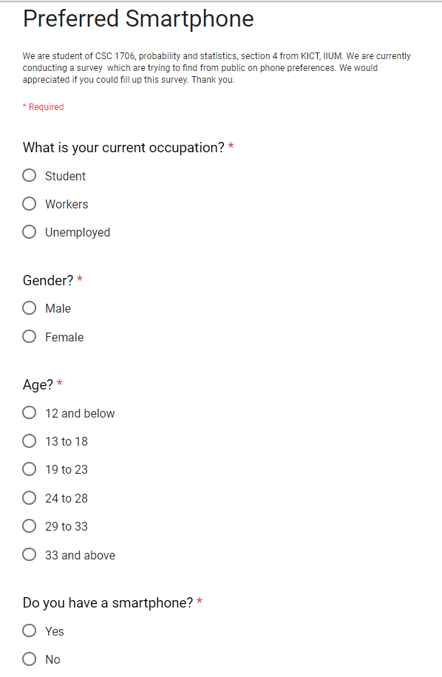

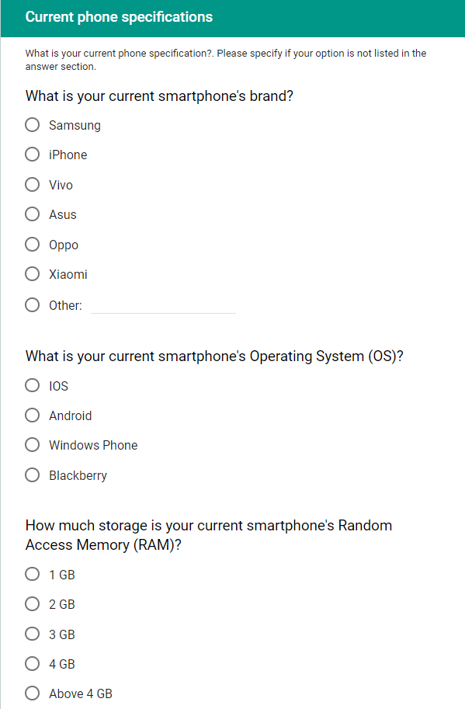

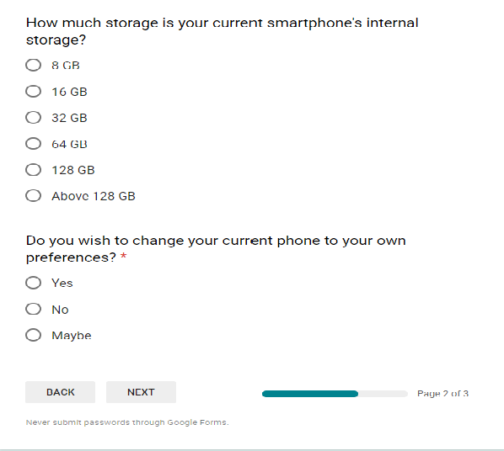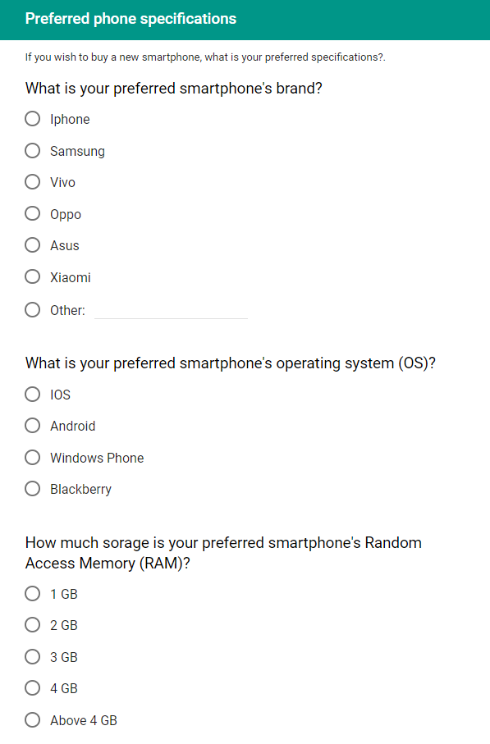

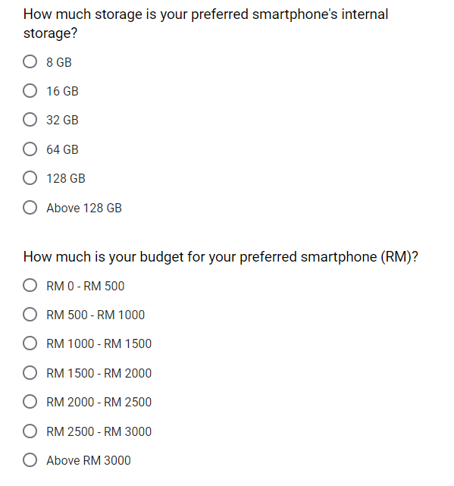

Good sample of online survey

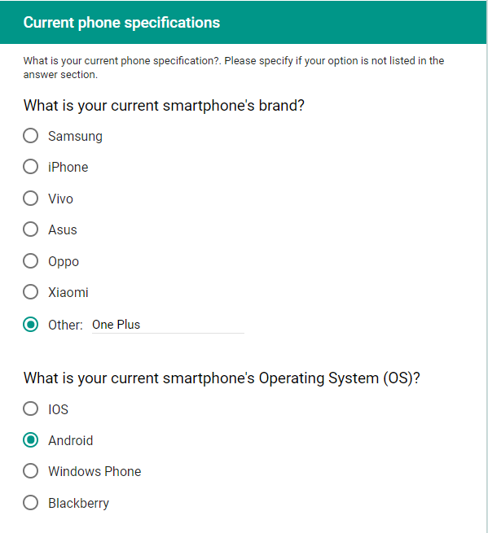

A good sample of respond for the brand, give correct smartphone’s brand name.

Bad sample of online survey

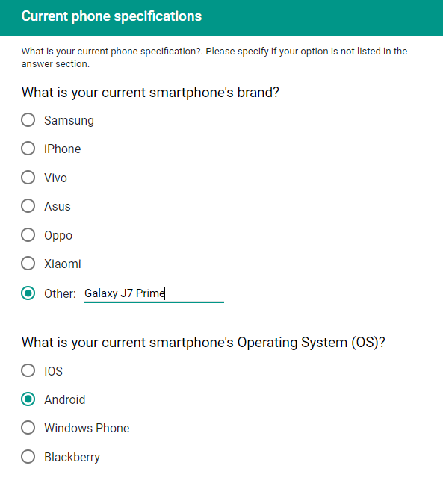

A bad sample of respond for the smartphone’s brand, give smartphone’s model name instead of brand name.